COP3223: Section 2 Understanding the Picture Processing Program, assign4.c

The picture processing program helps us manipulate images. The differences between the food bank program you wrote and this one fall into three topics.

Topic 1: Functions
A function is a set of statements having their own variations of what it’ll do within a code. While these are somewhat related to math functions, the key idea important now is that as in math functions, a function block has to go away and do some work and come back with an answer. The concept of going away is the important concept here.
You are already familiar with the function main which may have shown up as
int main ( ) or void main or something like that. After this title (header) line, the body of the function is enclosed between open curly bracket and closed curly bracket. So now the program can add new functions. It just needs the function title line and the body within the curly brackets.
And then this complete function (title line and body) must be added after all of function main. Each new function block represents a piece of work that the computer will go away and do and come back with an answer for. Thus we can have many functions after main.
After these functions have been defined and (fully) included below main, they need to be called from within main. A function call merely uses the function name and provides the list of (actual) parameters that the function said it needed in the function title line below main. In the title line, these are called formal parameters.
You have already called functions without knowing this. Such examples were printf, scanf, system, strcpy and strcmp. These functions were pre-defined in the .h files that are included at the top of the program.

One other thing, the function title line from its definition below main needs to be copied above main, but this time it needs a semi colon at the end of this line.

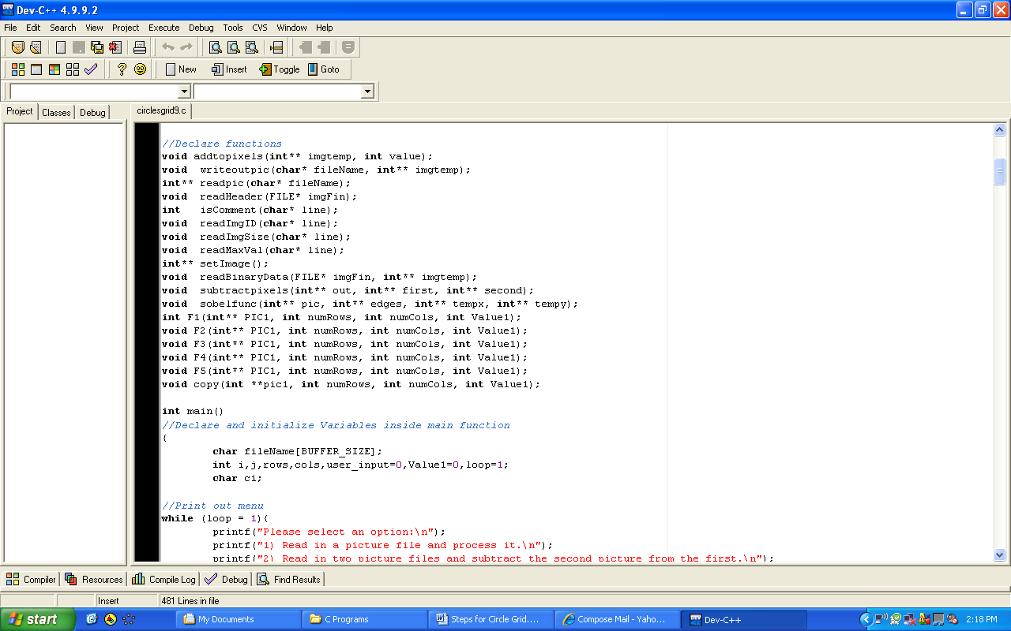

The declared functions will be similar as the function blocks after the main, except they end in semi colons.

Each function block must have an open curly bracket before writing out the function body followed by a closed curly bracket.

The function has to have a header introducing the line.
Example: void addtopixels (int** imgtemp, intValue1) {
- Notice the open curly bracket at the end, which is where the body should begin.
- Here is an example of a function block (from the lower part of the program):
void addtopixels (int** imgtemp, int value){
int i, j;

for (i=0;i<numRows;i++)
{
for (j=0;j<numCols;j++)
{
Imgtemp[i][j] += value;;
}
}
}

Topic 2: - Some Function blocks contain int** in the title line.

int** is simply a 2 dimensional array. It is like saying int arrayname[20][20]

int** could have been used for the words that are printed out in the food bank program. The words bread and milk are divided into individual letters, and each letter is stored in a cell in the array. (A single word is a one-dimensional array, or also known as a string; the collection of words is the two dimensional array).

Our pictures are stored in these 2 dimensional arrays. Note that due to the presence of a star in int**, this is a pass by reference parameter, and hence is changeable within the function, with the changes being available to the caller. This enables the function to cause a change or an update, even though it is void.

Topic 3: In the food bank program, we read from the keyboard; now we will read from pre-existing files that contain the pictures. So this program reads from files, but you do not need to know the details of this process. All we need to know is that we can use the array of pixels after the reading in has been completed by readpic. Readpic returns through its name a completed two-dimensional array (i.e., an array that has had its memory given to it as requested, and also has been fully read into). When you are going to create functions that return (new) arrays, you will need to employ the use of setImage. setImage will request (from the system) a new array and will also request that the array be given memory as needed by the size of the picture. The size of the picture is available to the program through the variables named numRows and numCols, which in turn are given values by readpic, which reads them from the picture file.

